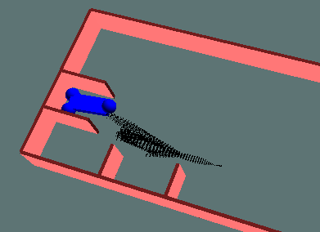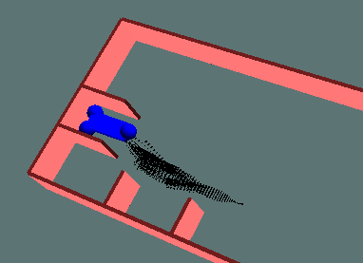
Step angle = 0.2 Step angle = 0.3
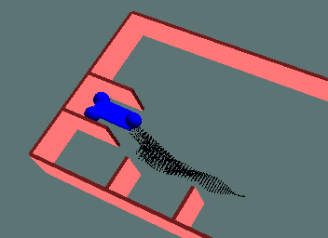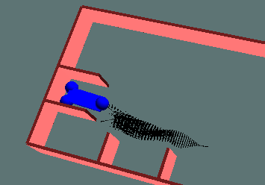
Step angle = 0.4 Step angle = 0.5

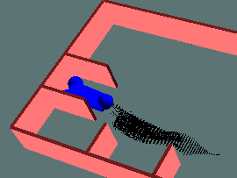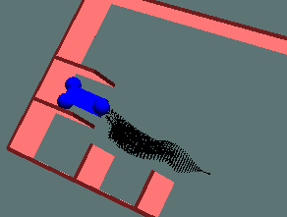
Step angle = 0.6 Step angle = 0.7

TABLE 2
Comparison of Garage Parking Performance using different incremental steer step (a=1, b=4)
Steering Step | Straight  Distance | Path Length | Residue  Error | Running time  (Second)
0.2 | 9.2665 | 9.3872 |  | 31.74
0.3 | 9.3161 | 9.4532 |  | 28.87
0.4 | 9.2823 | 9.4299 |  | 16.09
0.5 | 9.1791 | 9.2970 |  | 46.01
0.6 | 9.1791 | 9.2970 |  | 48.40
0.7 | 9.1791 | 9.2970 |  | 55.70

TABLE 3
Comparison of Garage Parking Performance using different incremental steer step (a=1, b=0)

Steering Step | Straight  Distance | Path Length | Running time  (Second)
0.2
0.3 | 9.3176 | 9.4385 | 9.43
0.4 | 9.2001 | 9.2872 | 24.07
0.5 | 9.2529 | 9.3398 | 30.22
0.6 | 9.2529 | 9.3398 | 29.47
0.7 | 9.2529 | 9.3398 | 33.10

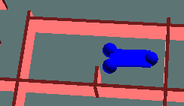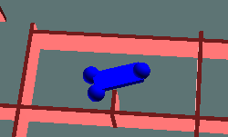
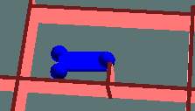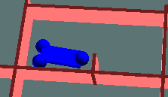

Step angle = 0.2 Step angle = 0.3
Step angle = 0.4 Step angle = 0.5

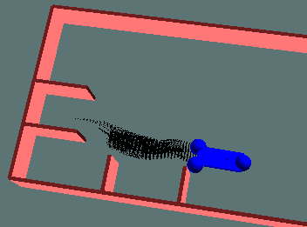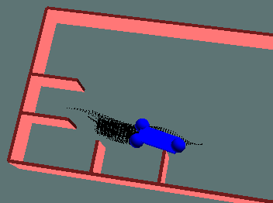
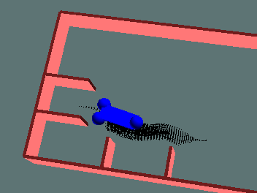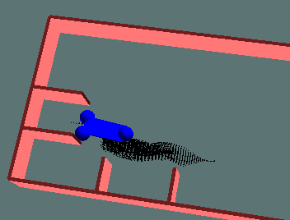

(1) (2)
(3) (4)
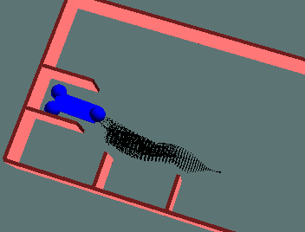
Fig. 1. The four representative positions of car robot while parking along the path of minimum cost found in reverse garage parking experiment:(1)→(2)→(3) →(4).

